**DEPLOYMENT MANUAL**

SARS COVID-19 DETECTION THROUGH AI

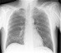Using our android application we determine sars covid-19  by scanning the reports i.e. x rays whether the victim is affected covid positive or covid negative in simple Terminology victim is suffering from covid or not.

Download our application from Github.

The github wiki link :[-https://github.com/htmw/2023S-Team4/wiki/](https://github.com/htmw/2023S-Team4/wiki/)

Open the below link and download the application from our wiki page

Install the android studio from the web browser : https://developer.android.com/studio

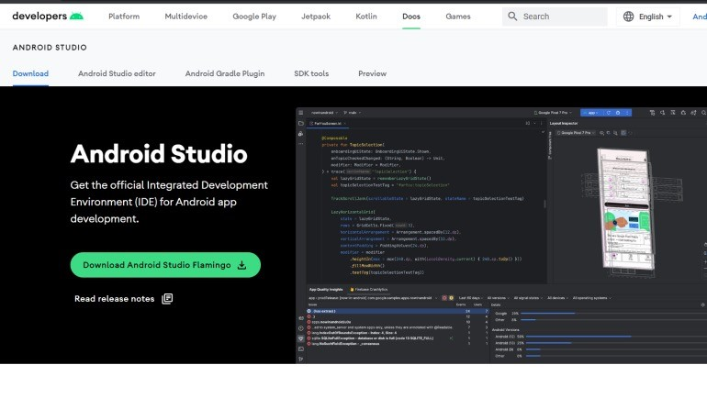

After the installing the android studio , open the application



Interface after opening the android studio

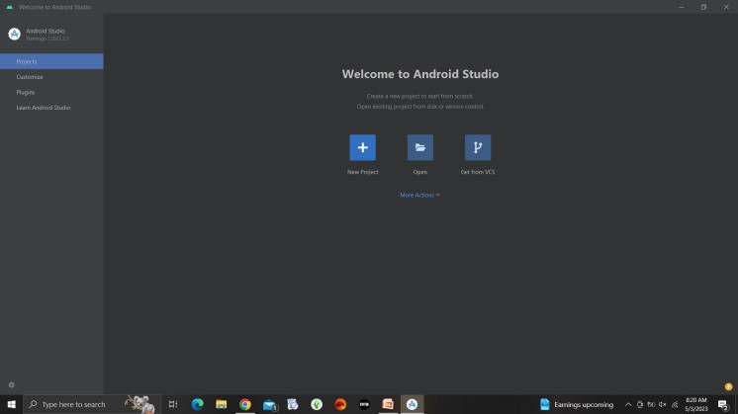

Import the project , click on open the project as given below

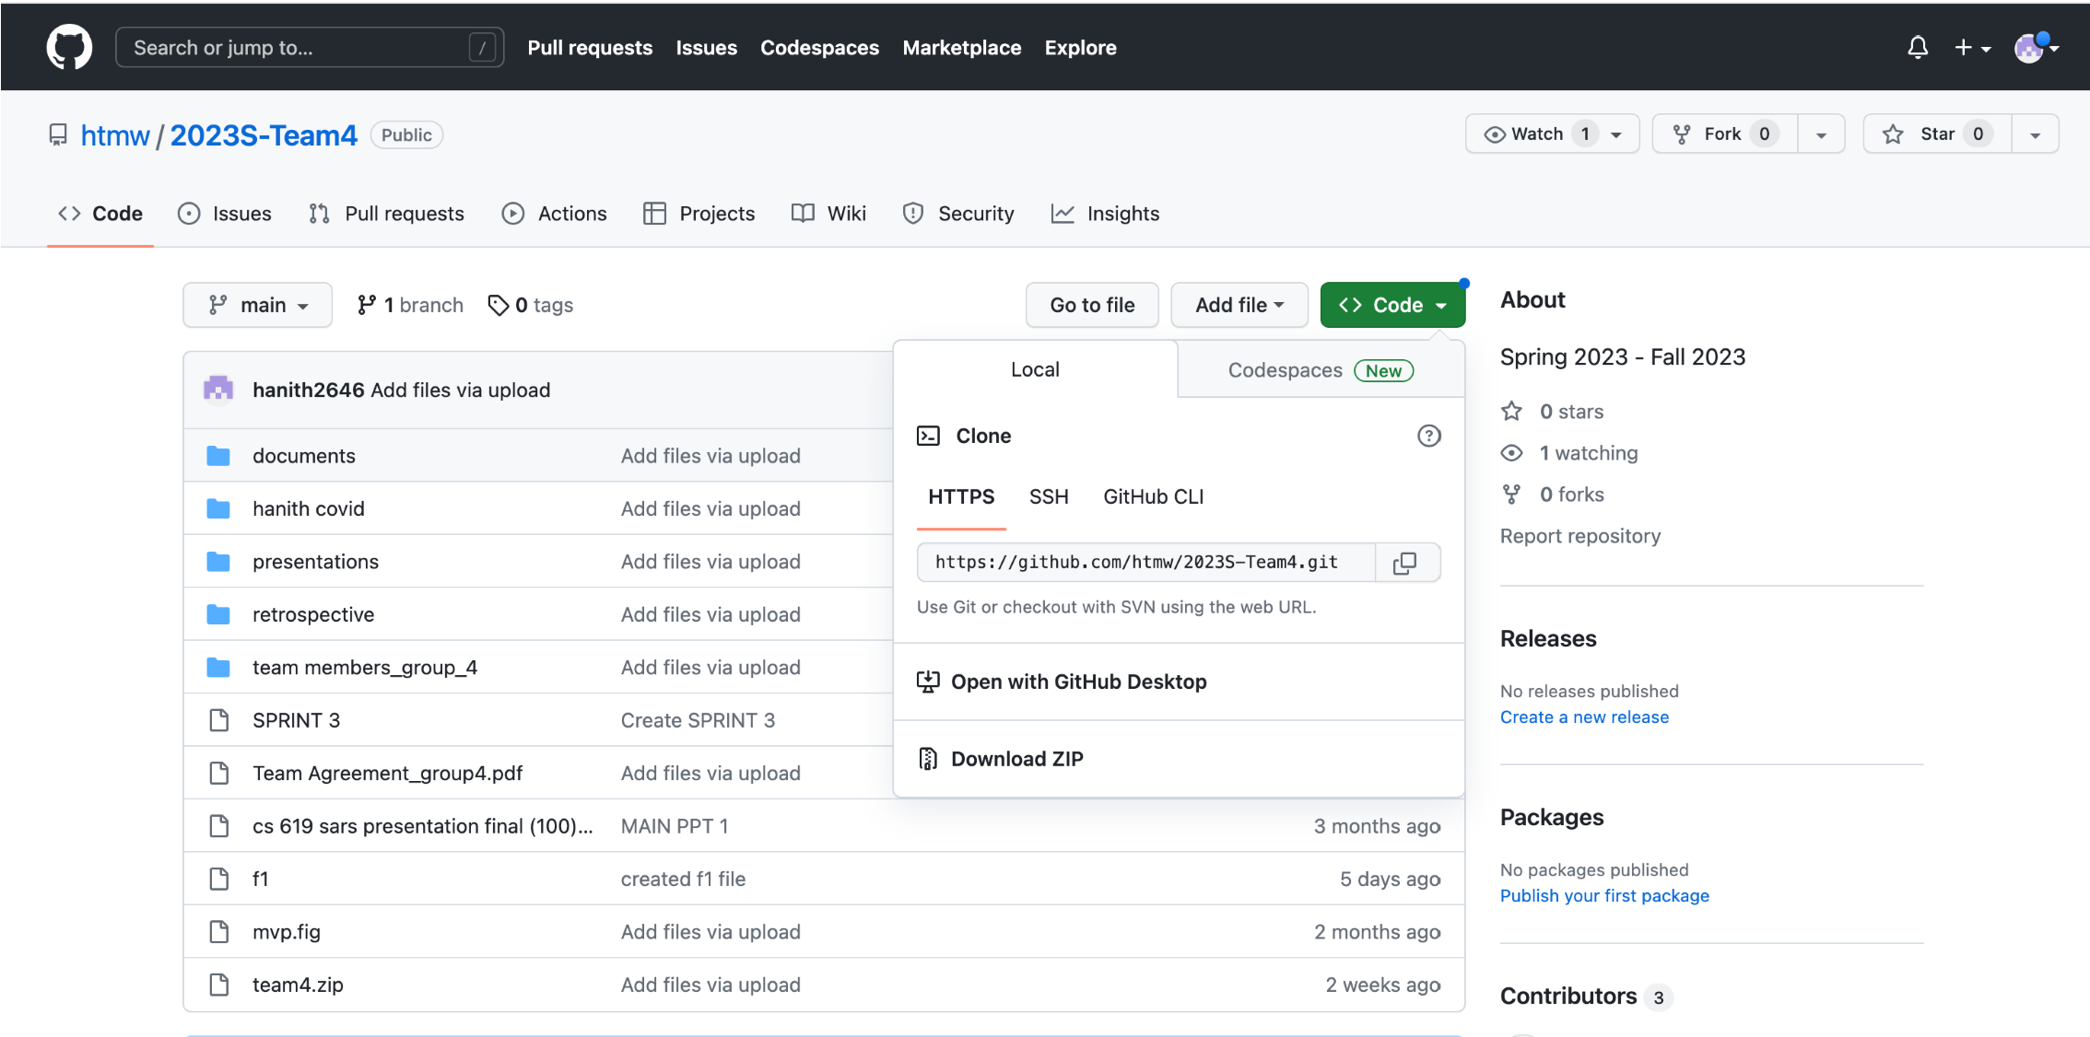

To clone the code in the github we need to copy and paste

the HTTPS link into VCS in the android studio

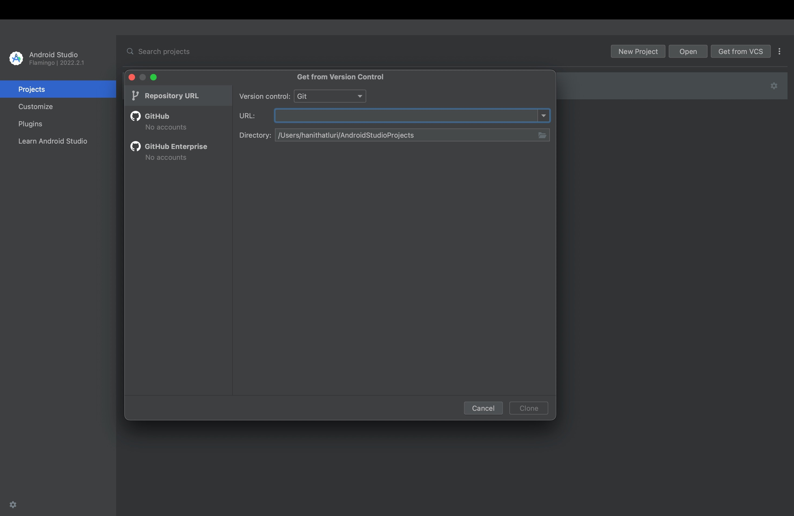

Here, In android studio we can submit the HTTPS lick to clone the code

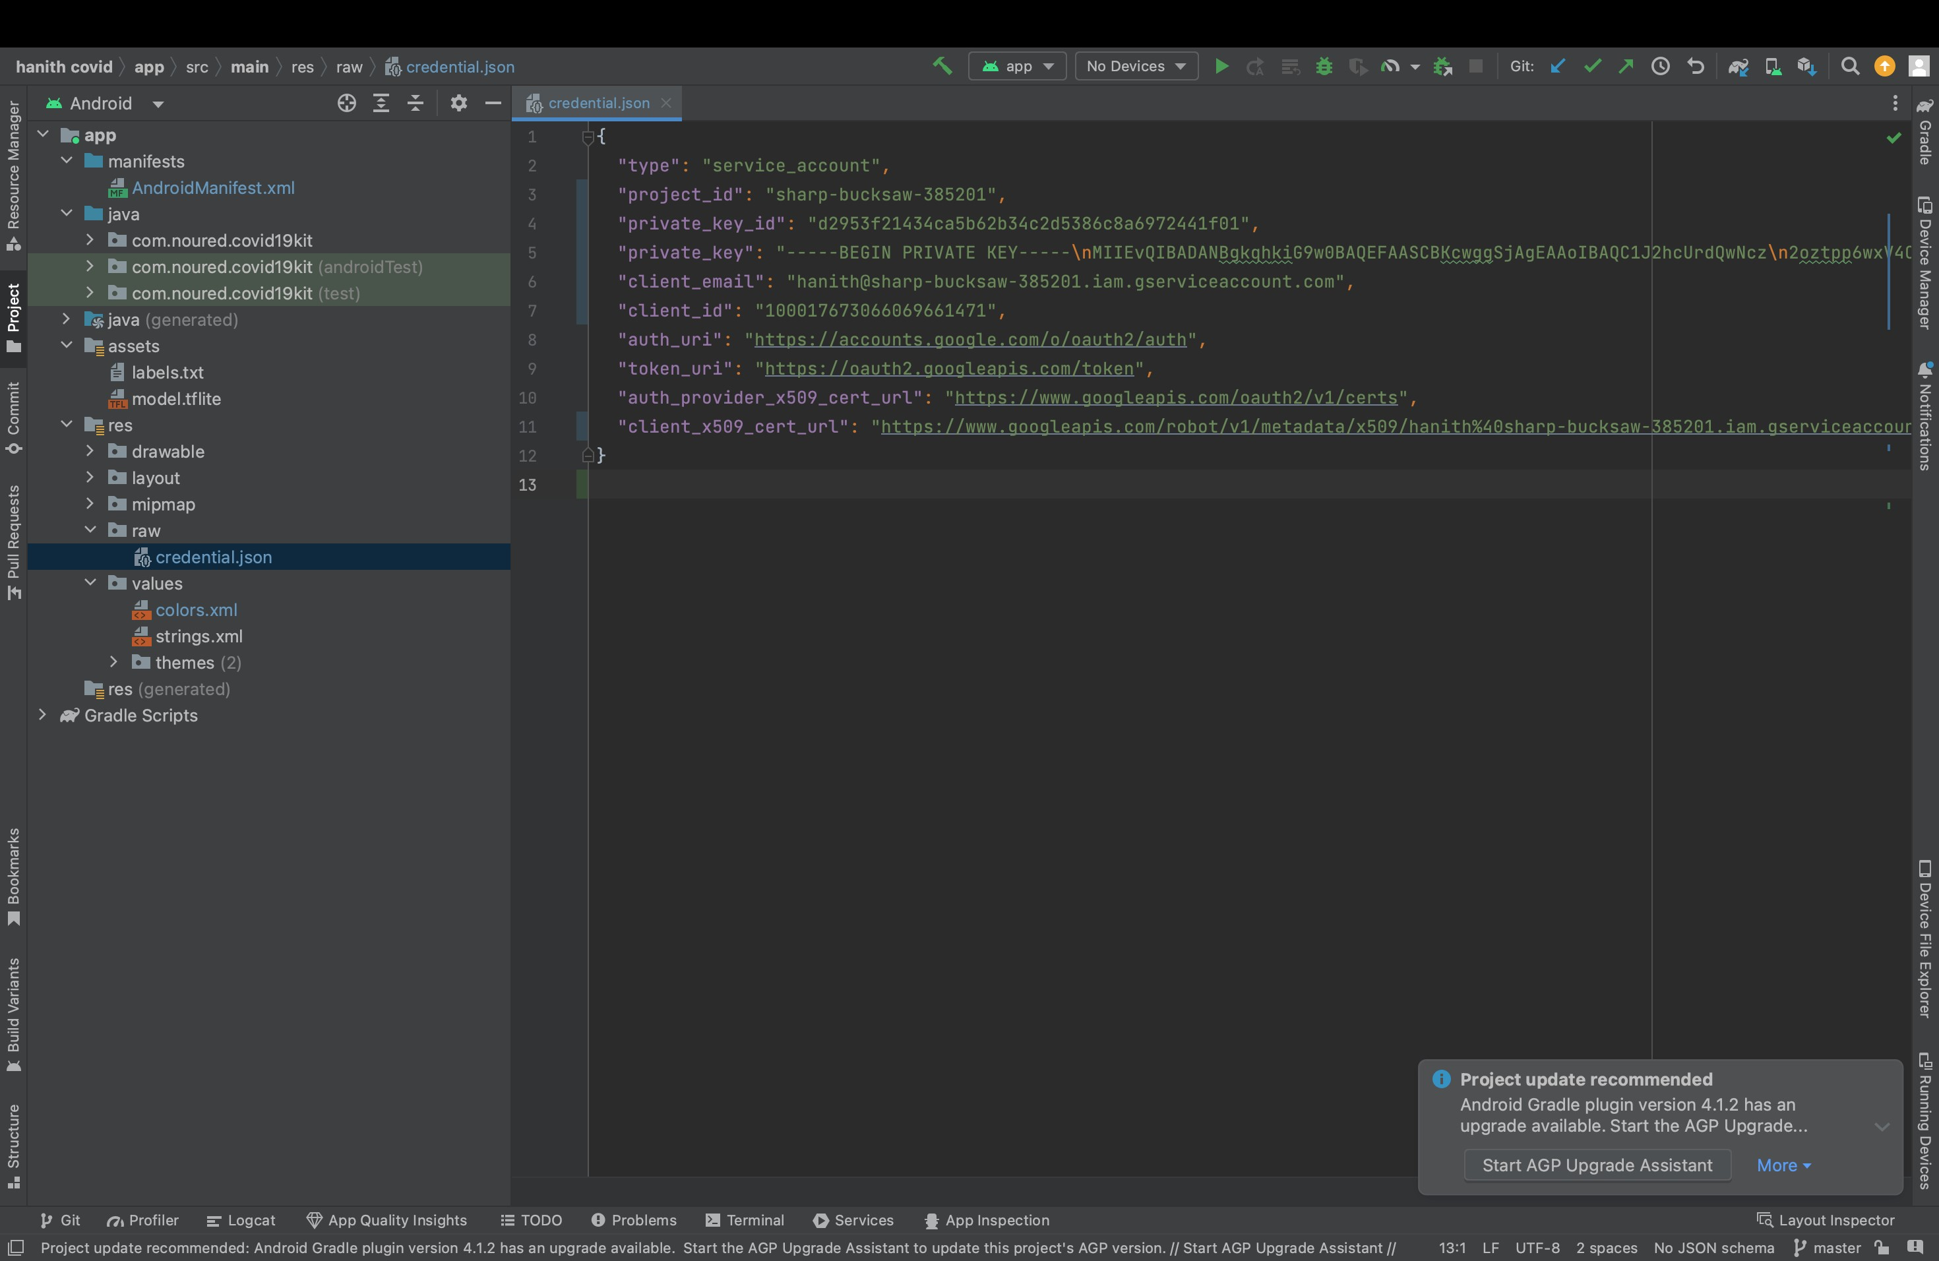

It will be directed into the home page where we have done project will all credentials and homeactivity page, login activity page.